Test Environment and Test Releases in Xray Jira

Test Environments in Xray Jira

Choose xray under apps (marketplace apps):

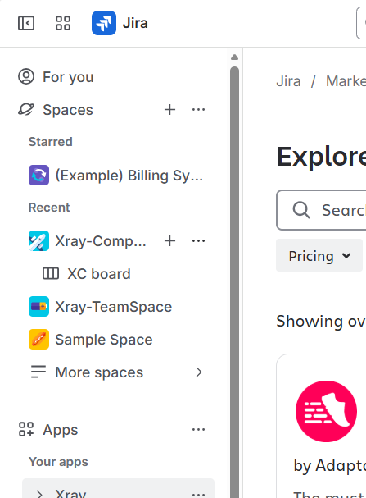

select configure project and choose the required project:

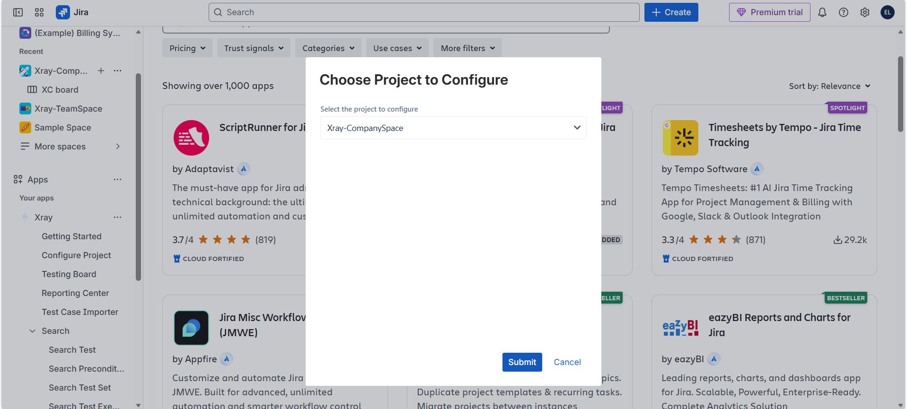
Select Test Environments and get to create Environment (new) or add environment from already existing environments (global level) :

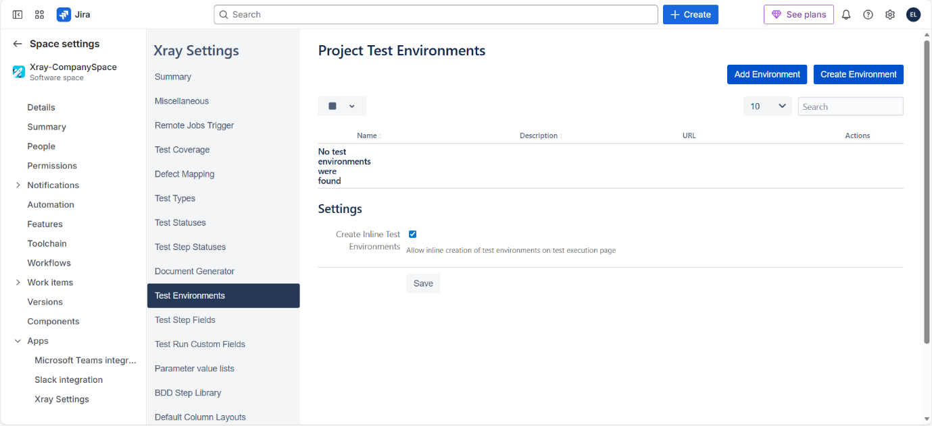

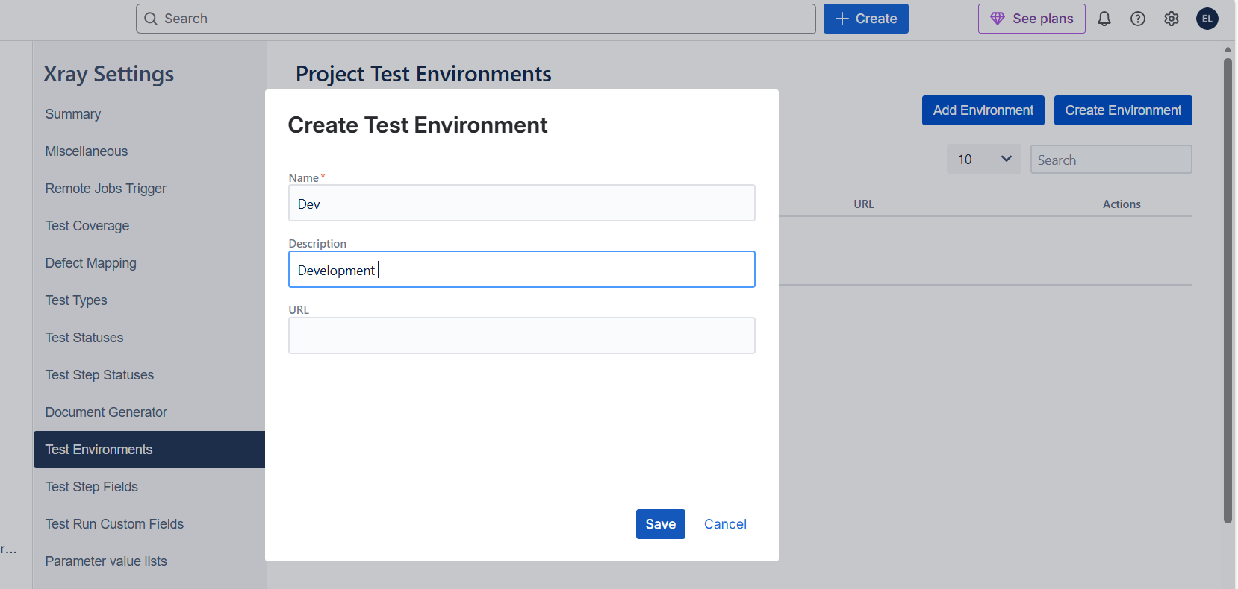

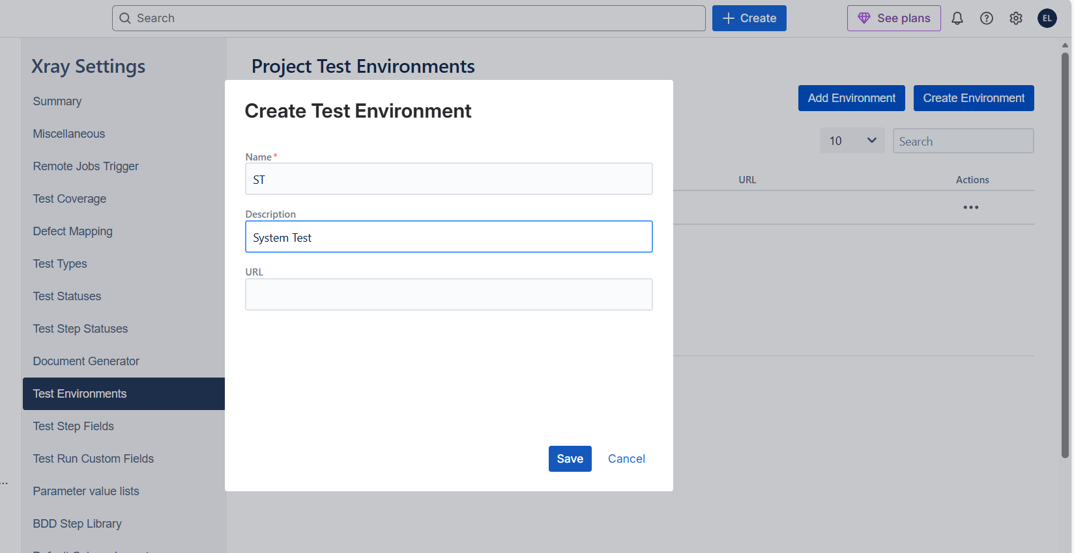

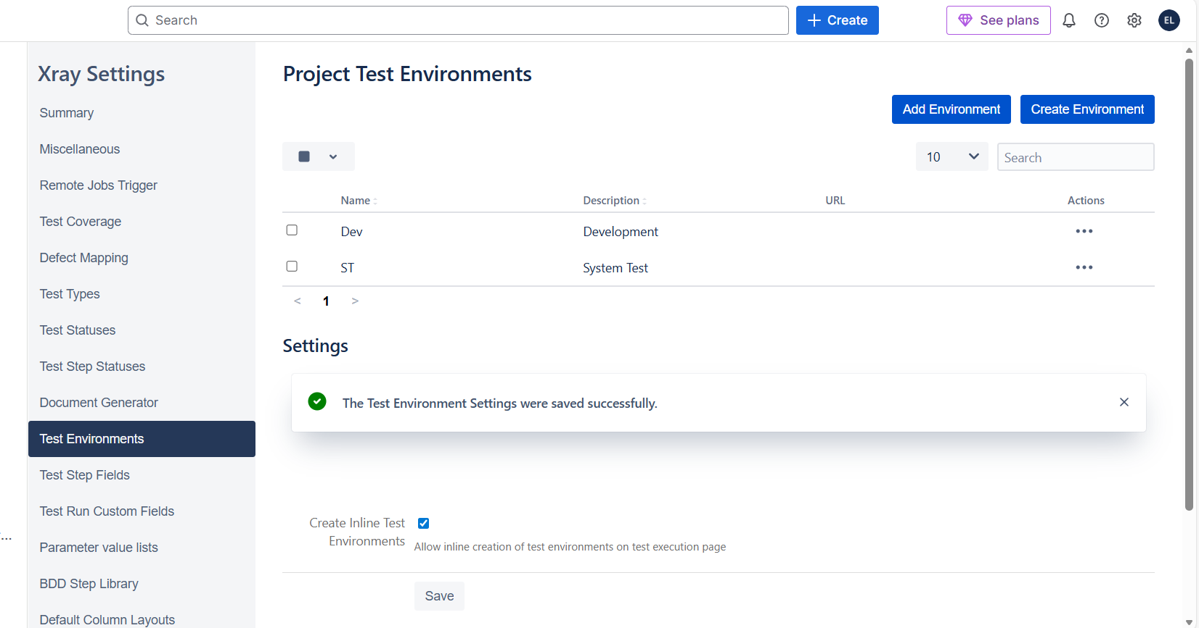

So far, created two environments. But let’s say to add enviroments, they have to be already created environments in the global level. So, now let’s create environments in global level through settings at the top navigation bar.

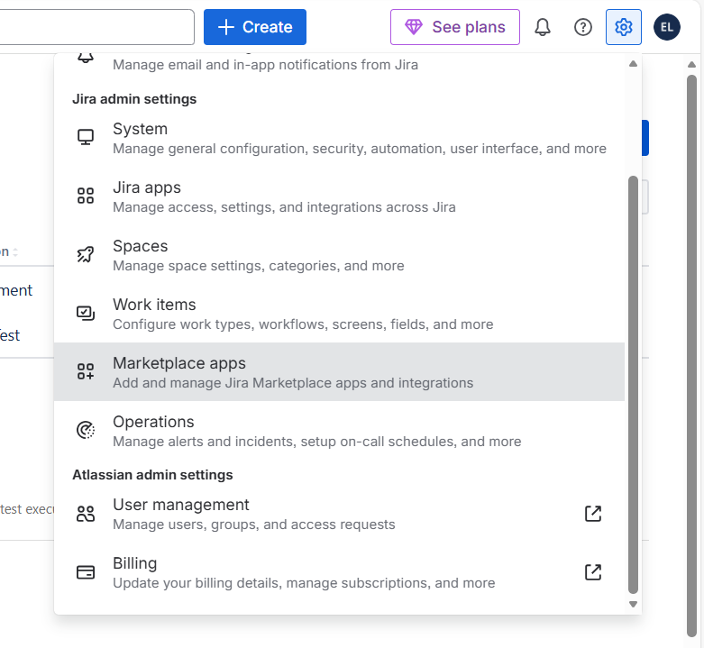
Select Marketplace apps
As part of Jira admin settings, Choose Test Environments
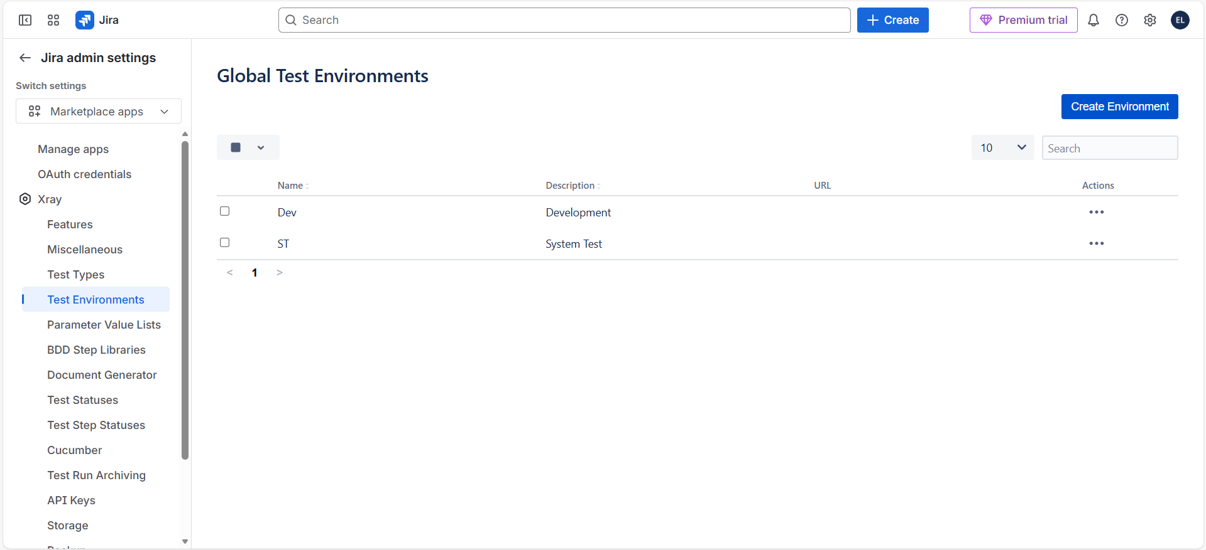
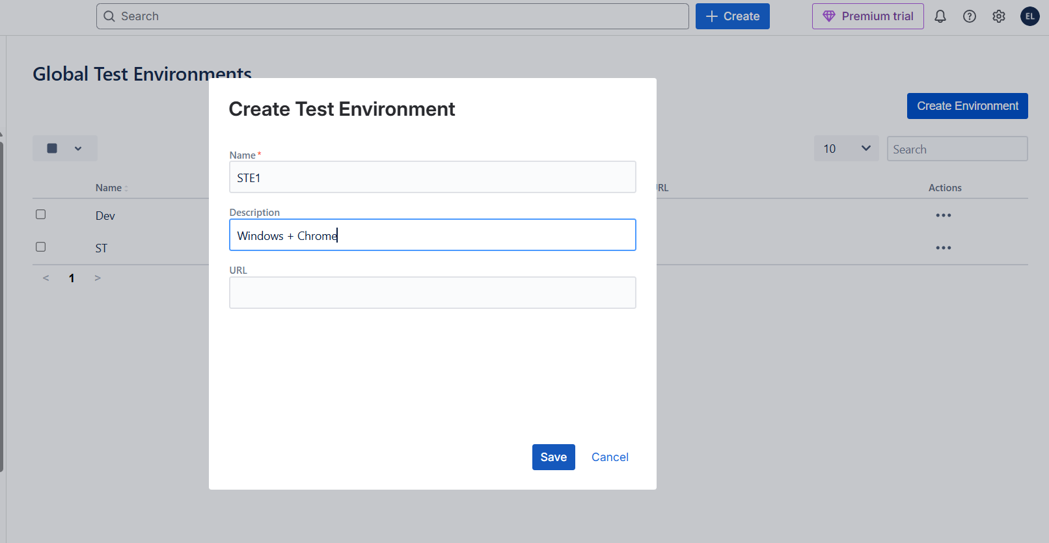

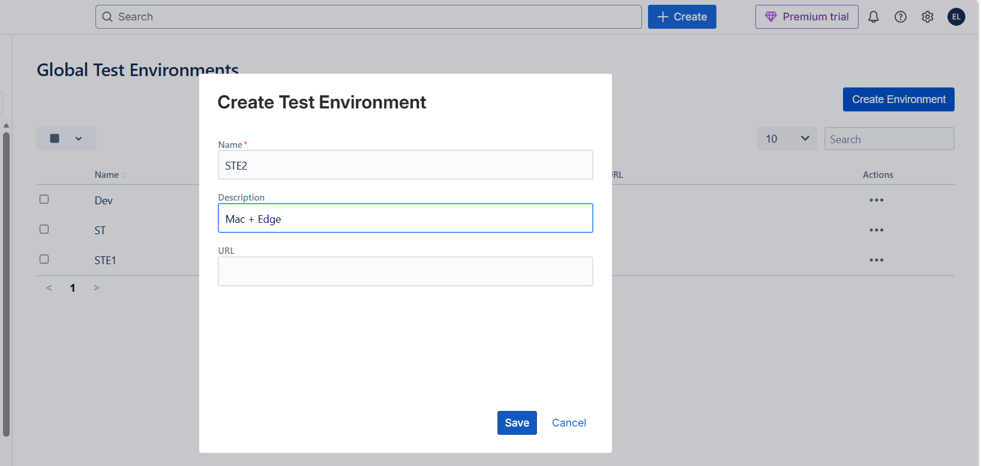

Now, let’s open other project and see if we can find the above global test environments we have created.

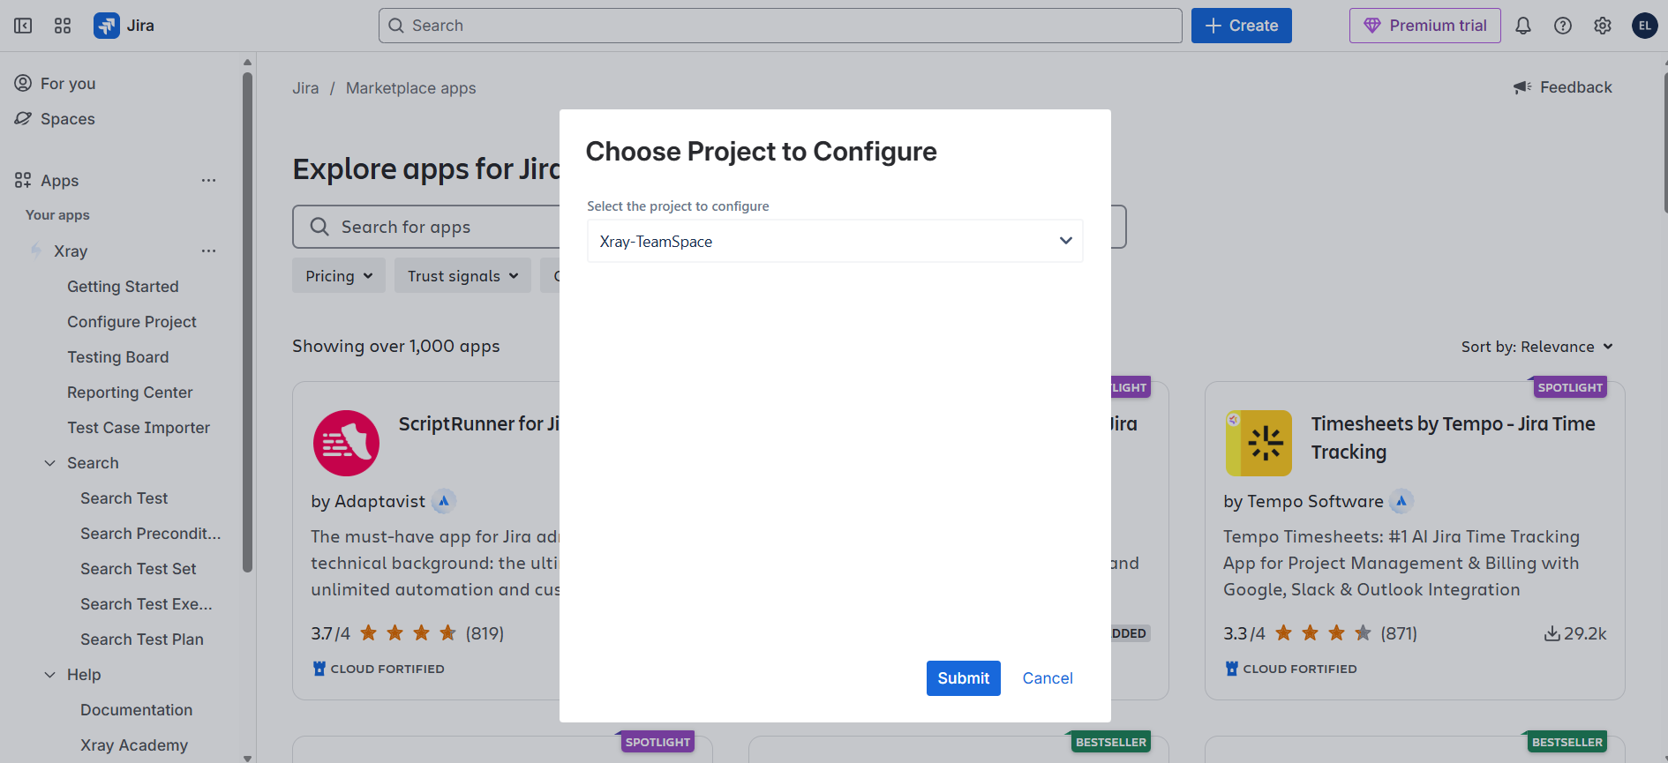

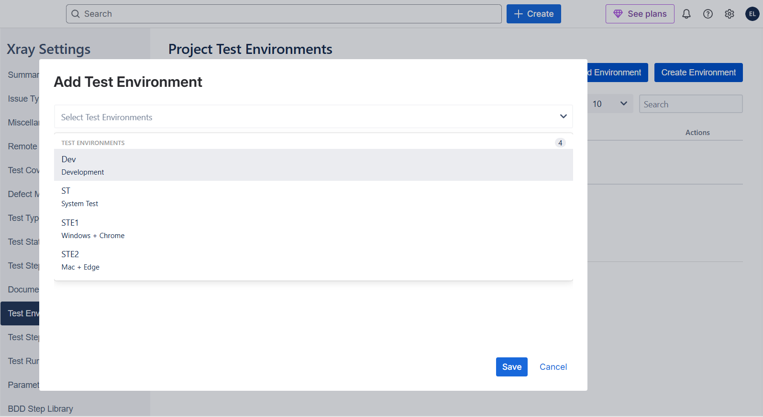

Test Environment is used in real life software development by the testers to do checking in specific environments and trace the pass/failure of the test executions corresponding to the specific eenvironment. Test Environemnt can be Windows + Chrome or Mac + Edge etc.,

Software Releases in Xray:

When a project is big, and the time estimate to complete the project can be 3 months, then features are developed one by one and project will be released with completed features upto that every month and we call it as a release.

To create releases for your project, simply go to space settings of the project/space:

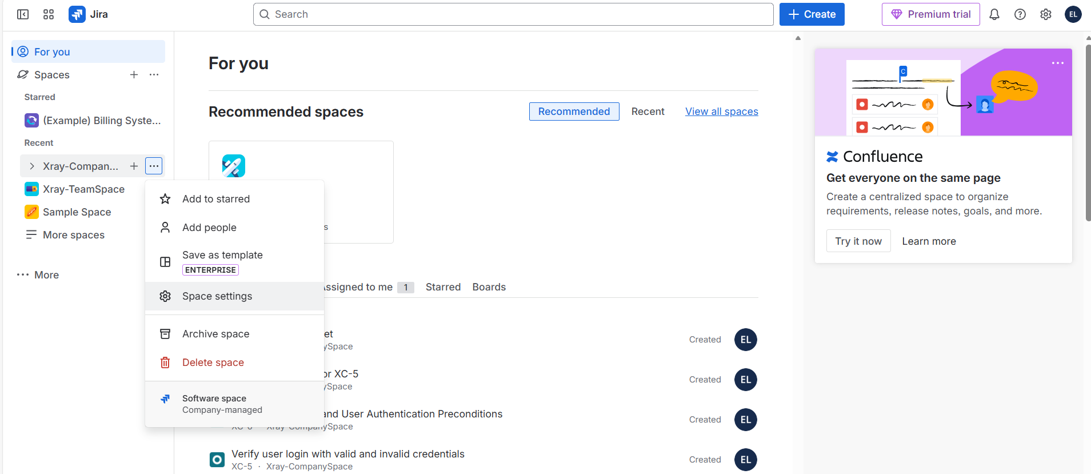

Choose Versions then:

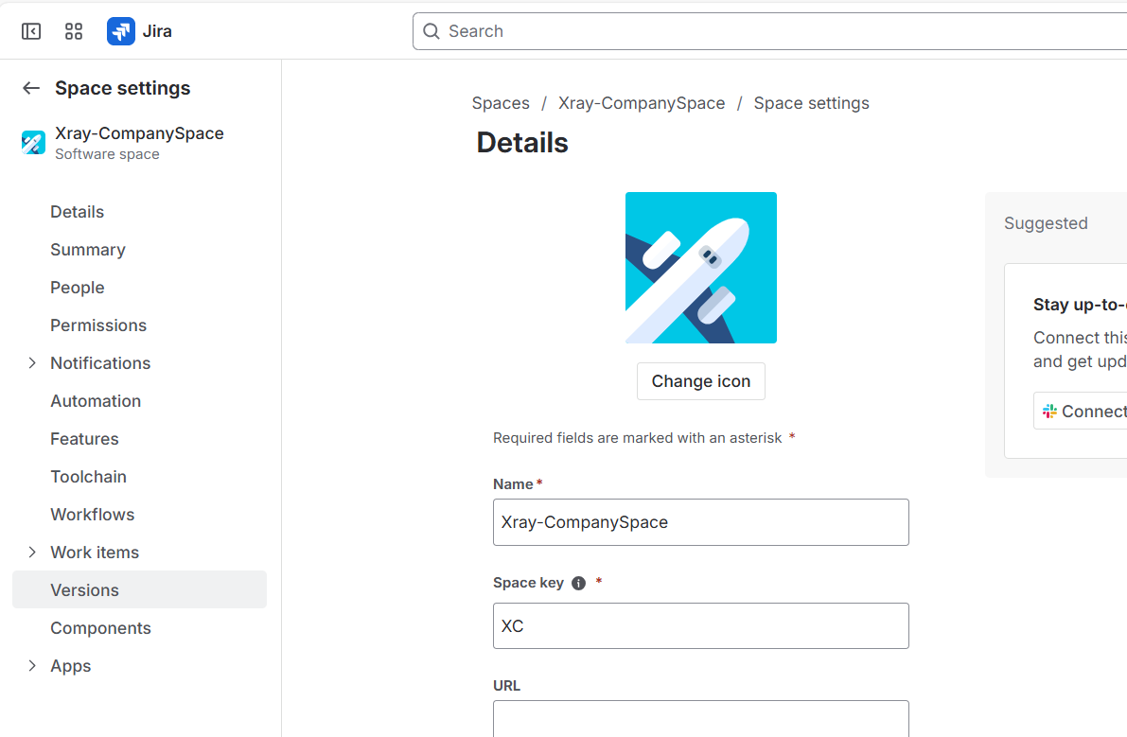

Click on Create Release:

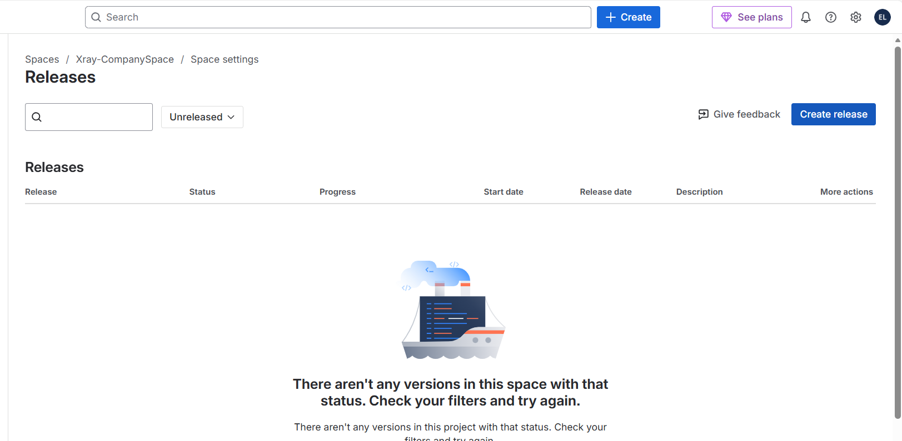

Name the release according to the user stories that are finished or something meaningful so that it would be easy to manage later for the automations and stuff. For every work item, you can tag this releases you created so that automation works get easier
